This is a Precision Packed Foldup Bicycle

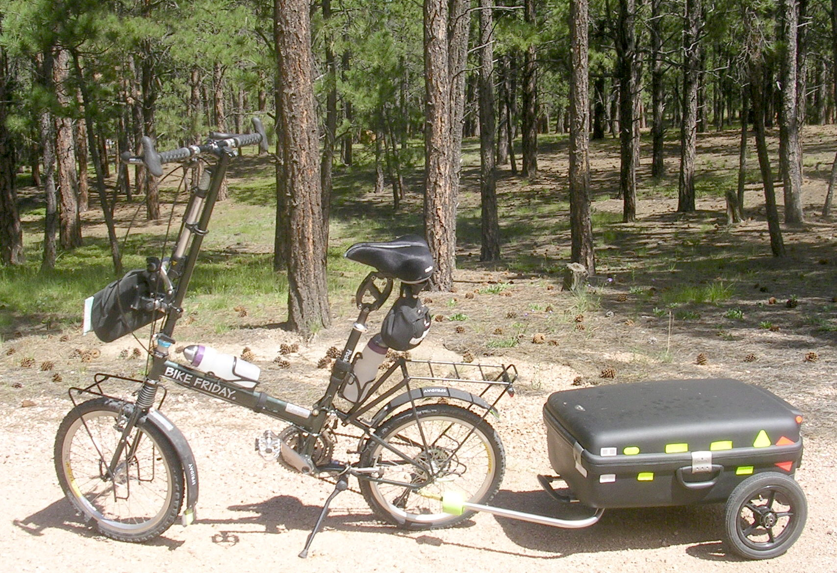

Bicycle Components ONLY

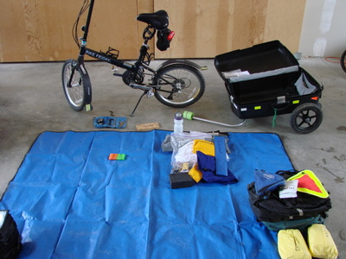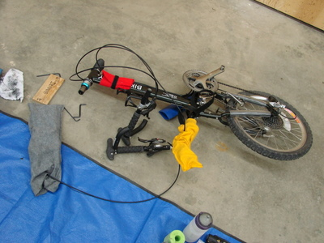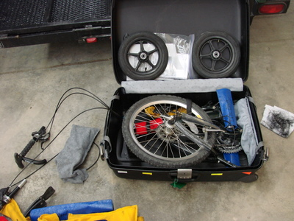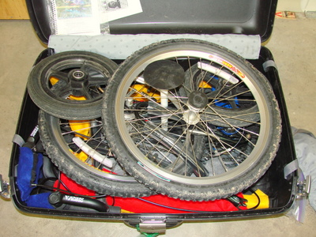

Owners: Dennis Struck (USA 1.719.439.2766 )
Terry Struck (USA 1.719.331.9177 )

Problem? We're in the Airport, please Call or Page.

Manufacturer: Bike Friday, International: (USA code) 541-687-0487; In USA 1-800-777-0258
3364 W 11th Avenue, Eugene, Oregon, 97402, USA

Packing Instructions: Enclosed

