This is a Precision Packed Foldup Bicycle
This is what it looks like assembled
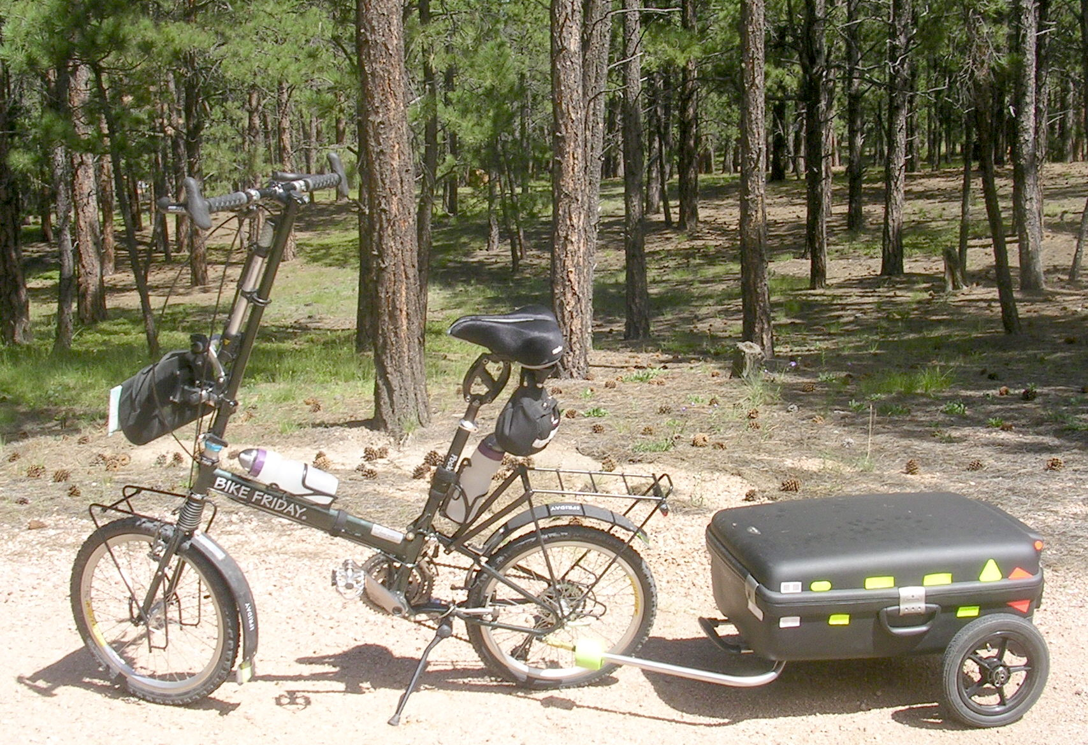
Bicycle Components ONLY in Suitcase

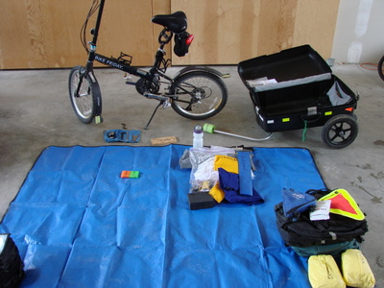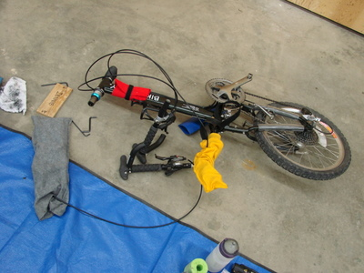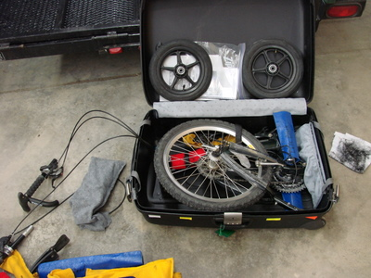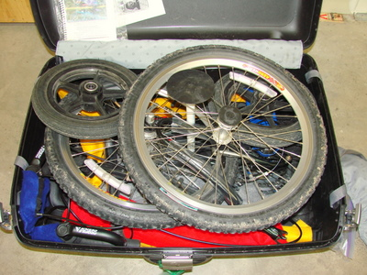

Owners: ___________________ (USA 1.____.____.______)
___________________ (USA 1.____.____.______)

Problem? We're in the Airport, please Call or Page.

Manufacturer: Bike Friday, International: (USA code) 541-687-0487; In USA 1-800-777-0258
3364 W 11th Avenue, Eugene, Oregon, 97402, USA

Packing Instructions: Enclosed

